Chapter 12, Problem 22.

Find the line currents I_{a}, I_{b}, and I_{c} in the three-phase network of Fig. 12.53 below. Take Z_{Δ} = (12 – j15) Ω, Z_{Y} = (4 + j6) Ω, and Z_{l} = 2 Ω.
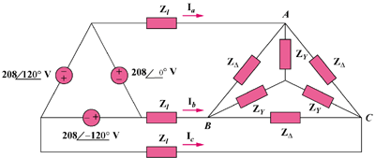

440∠0˚ V

440∠120˚ V

440∠–120˚ V

Figure 12.53
For Prob. 12.22.

